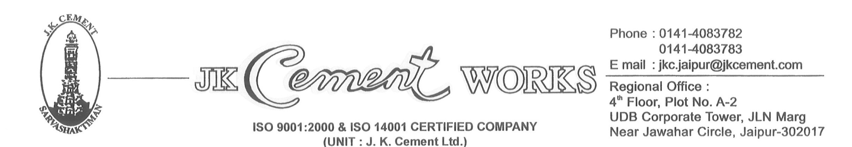

CIN: L17229UP1994PLC017199

Dear Stockiest 30.07.2021

M/S RADHEY SHYAM CEMENT AGENCY (201143)

DHOLPUR

**We are enclosing herewith rate difference detail as communicated to you on day to day basis early morning to** be allowed during the period JULY’21 & we shall issue the credit note mentioning GST separately on the credit note itself. We would request you to reverse the GST amount, which would be mentioned on the credit note, from the input tax credit. However, if JK CEMENT incurs any financial liability due to non-reversal of the GST amount, as mentioned earlier, the same will be recovered from you.

Thanking you,

For J K Cement Ltd

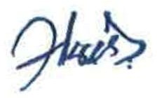

Regional Manager- Marketing



CIN: L17229UP1994PLC017199

Dear Stockiest 25.10.2021

M/S RADHEY SHYAM CEMENT AGENCY (201143)

DHOLPUR

**We are enclosing herewith rate difference detail as communicated to you on day to day basis early morning to** be allowed during the period OCT’21 & we shall issue the credit note mentioning GST separately on the credit note itself. We would request you to reverse the GST amount, which would be mentioned on the credit note, from the input tax credit. However, if JK CEMENT incurs any financial liability due to non-reversal of the GST amount, as mentioned earlier, the same will be recovered from you.

Thanking you,

For J K Cement Ltd



Regional Manager- Marketing



CIN: L17229UP1994PLC017199

Dear Stockiest 25.11.2021

M/S RADHEY SHYAM CEMENT AGENCY (201143)

DHOLPUR

**We are enclosing herewith rate difference detail as communicated to you on day to day basis early morning to** be allowed during the period NOV’21 & we shall issue the credit note mentioning GST separately on the credit note itself. We would request you to reverse the GST amount, which would be mentioned on the credit note, from the input tax credit. However, if JK CEMENT incurs any financial liability due to non-reversal of the GST amount, as mentioned earlier, the same will be recovered from you.

Thanking you,

For J K Cement Ltd



Regional Manager- Marketing